**Introduction to EntityFrameworkCore**

EntityFrameworkCore is light-weight, extensible and cross-platform framework for accessing databases in .NET applications.

It is the most-used database framework for Asp.Net Core Apps.

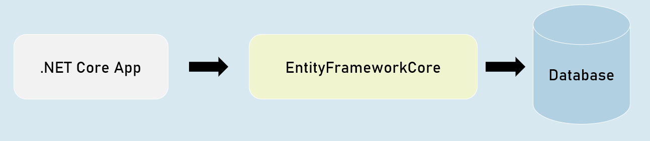

**EFCore Models**

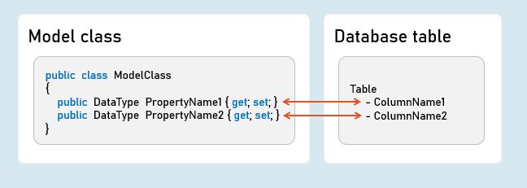

**Pros & Cons of EntityFrameworkCore**

**Shorter Code**

The CRUD operations / calling stored procedures are done with shorter amount of code than ADO.NET.

**Performance**

EFCore performs slower than ADO.NET.

So ADO.NET or its alternatives (such as Dapper) are recommended for larger & high-traffic applications.

**Strongly-Typed**

The columns as created as properties in model class.

So the Intellisense offers columns of the table as properties, while writing the code.

Plus, the developer need not convert data types of values; it's automatically done by EFCore itself.

**Approaches in Entity Framework Core**

**EFCore Approaches**

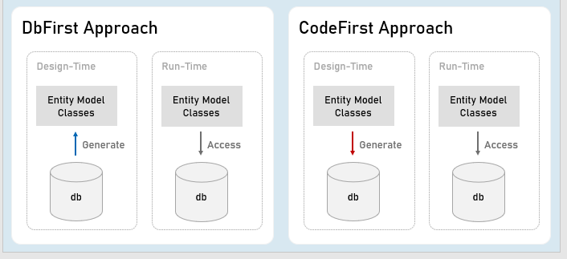

**Pros and Cons of EFCore Approaches**

**CodeFirst Approach**

Suitable for newer databases.

Manual changes to DB will be most probably lost because your code defines the database.

Stored procedures are to be written as a part of C# code.

Suitable for smaller applications or prototype-level applications only; but not for larger or high data-intense applications.

**DbFirst Approach**

Suitable if you have an existing database or DB designed by DBAs, developed separately.

Manual changes to DB can be done independently.

Stored procedures, indexes, triggers etc., can be created with T-SQL independently.

Suitable for larger applications and high data-intense applications.

**DbContext and DbSet**

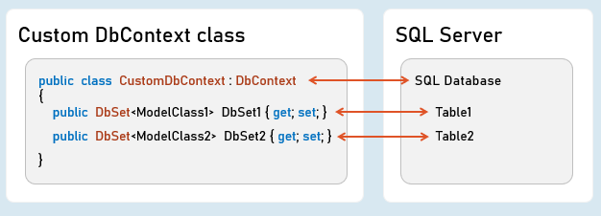

**DbContext**

An instance of DbContext is responsible to hold a set of DbSets' and represent a connection with database.

**DbSet**

Represents a single database table; each column is represented as a model property.

**Add DbContext as Service in Program.cs:**

builder.Services.AddDbContext<DbContextClassName>( options => {

options.UseSqlServer();

}

);

**Code-First Migrations**

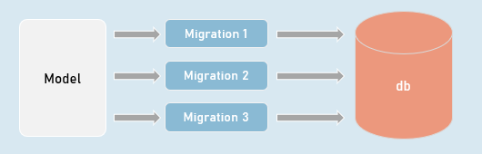

**Migrations**

Creates or updates database based on the changes made in the model.

in**Package Manager Console (PMC):**

Add-Migration MigrationName

//Adds a migration file that contains C# code to update the database

Update-Database -Verbose

//Executes the migration; the database will be created or table schema gets updated as a result.

**Seed Data**

in DbContext:

modelBuilder.Entity<ModelClass>().HasData(entityObject);

It adds initial data (initial rows) in tables, when the database is newly created.

**EF CRUD Operations - Query**

**SELECT - SQL**

SELECT Column1, Column2 FROM TableName

WHERE Column = value

ORDER BY Column

**LINQ Query:**

_dbContext.DbSetName

.Where(item => item.Property == value)

.OrderBy(item => item.Property)

.Select(item => item);

//Specifies condition for where clause

//Specifies condition for 'order by' clause

//Expression to be executed for each row

**EF CRUD Operations - Insert**

**INSERT - SQL**

INSERT INTO TableName(Column1, Column2) VALUES (Value1, Value2)

**Add:**

_dbContext.DbSetName.Add(entityObject);

//Adds the given model object (entity object) to the DbSet.

**SaveChanges()**

_dbContext.SaveChanges();

//Generates the SQL INSERT statement based on the model object data and executes the same at database server.

**EF CRUD Operations - Delete**

**DELETE - SQL**

DELETE FROM TableName WHERE Condition

**Remove:**

_dbContext.DbSetName.Remove(entityObject);

//Removes the specified model object (entity object) to the DbSet.

**SaveChanges()**

_dbContext.SaveChanges();

//Generates the SQL DELETE statement based on the model object data and executes the same at database server.

**EF CRUD Operations - Update**

**UPDATE - SQL**

UPDATE TableName SET Column1 = Value1, Column2 = Value2 WHERE PrimaryKey = Value

**Update:**

entityObject.Property = value;

//Updates the specified value in the specific property of the model object (entity object) to the DbSet.

**SaveChanges()**

_dbContext.SaveChanges();

//Generates the SQL UPDATE statement based on the model object data and executes the same at database server.

**How EF Query Works?**

**Workflow of Query Processing in EF**

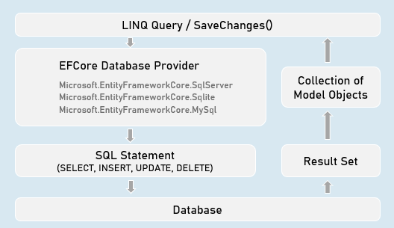

**EF - Calling Stored Procedures**

**Stored Procedure for CUD (INSERT | UPDATE | DELETE):**

int DbContext.Database.ExecuteSqlRaw(

string sql,

params object[] parameters)

//Eg: "EXECUTE [dbo].[StoredProcName] @Param1 @Parm2

//A list of objects of SqlParameter type

**Stored Procedure for Retrieving (Select):**

IQueryable<Model> DbSetName.FromSqlRaw(

string sql,

paramsobject[] parameters)

//Eg: "EXECUTE [dbo].[StoredProcName] @Param1 @Parm2"

//A list of objects of SqlParameter type

**Creating Stored Procedure (SQL Server)**

CREATE PROCEDURE [schema].[procedure_name]

(@parameter_name data_type, @parameter_name data_type)

AS BEGIN

statements

END

**Advantages of Stored Procedure**

**Single database call**

You can execute multiple / complex SQL statements with a single database call.

As a result, you'll get:

* Better performance (as you reduce the number of database calls)
* Complex database operations such as using temporary tables / cursors becomes easier.

**Maintainability**

The SQL statements can be changed easily WITHOUT modifying anything in the application source code (as long as inputs and outputs doesn't change)

**[Column] Attribute**

**Model class**

public class ModelClass

{

[Column("ColumnName", TypeName = "datatype")]

public DataType PropertyName { get; set; }

[Column("ColumnName", TypeName = "datatype")]

publicDataTypePropertyName { get; set; }

}

Specifies column name and data type of SQL Server table.

**EF - Fluent API**

**DbContext class**

public class CustomDbContext : DbContext

{

protected override void OnModelCreating(ModelBuilder modelBuilder)

{

//Specify table name (and schema name optionally) to be mapped to the model class

modelBuilder.Entity<ModelClass>( ).ToTable("table_name", schema: "schema_name");

//Specify view name (and schema name optionally) to be mapped to the model class

modelBuilder.Entity<ModelClass>( ).ToView("view_name", schema: "schema_name");

//Specify default schema name applicable for all tables in the DbContext

modelBuilder.HasDefaultSchema("schema_name");

}

}

public class CustomDbContext : DbContext

{

protected override void OnModelCreating(ModelBuilder modelBuilder)

{

modelBuilder.Entity<ModelClass>( ).Property(temp => temp.PropertyName)

.HasColumnName("column_name") //Specifies column name in table

.HasColumnType("data_type") //Specifies column data type in table

.HasDefaultValue("default_value") //Specifies default value of the column

}

}

public class CustomDbContext : DbContext

{

protected override void OnModelCreating(ModelBuilder modelBuilder)

{

//Adds database index for the specified column for faster searches

modelBuilder.Entity<ModelClass>( ).HasIndex("column_name").IsUnique();

//Adds check constraint for the specified column - that executes for insert & update

modelBuilder.Entity<ModelClass>( ).HasCheckConstraint("constraint_name", "condition");

}

}

**EF - Table Relations with Fluent API**

**Table Relations**

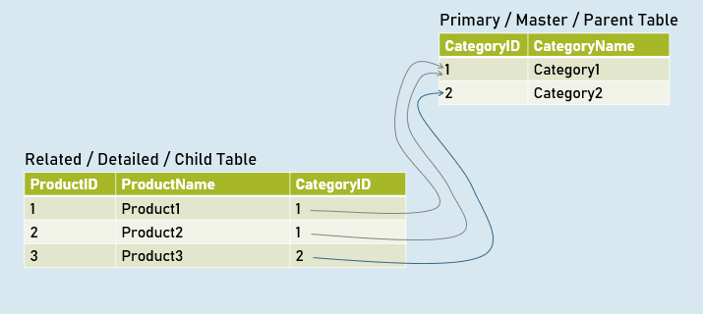

**EF - Table Relations with Navigation Properties**

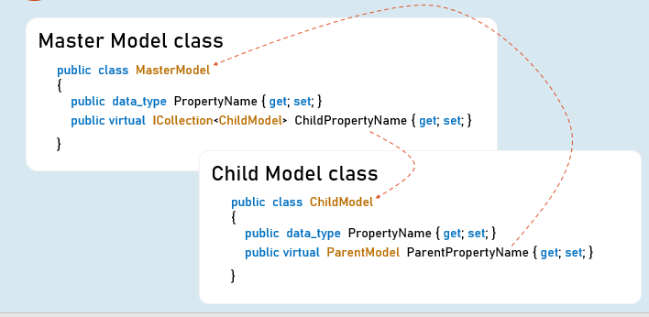

**EF - Table Relations with Fluent API**

**DbContext class**

public class CustomDbContext : DbContext

{

protected override void OnModelCreating(ModelBuilder modelBuilder)

{

//Specifies relation between primary key and foreign key among two tables

modelBuilder.Entity<ChildModel>( )

.HasOne<ParentModel>(parent => parent.ParentReferencePropertyInChildModel)

.WithMany(child => child.ChildReferencePropertyInParentModel) //optional

.HasForeignKey(child => child.ForeignKeyPropertyInChildModel)

}

}

**EF - Async Operations**

**async**

* The method is awaitable.
* Can execute I/O bound code or CPU-bound code

**await**

* Waits for the I/O bound or CPU-bound code execution gets completed.
* After completion, it returns the return value.

**Generate PDF Files**



**Rotativa.AspNetCore:**

using Rotativa.AspNetCore;

using Rotativa.AspNetCore.Options;

return new ViewAsPdf("ViewName", ModelObject, ViewData)

{

PageMargins = new Margins() { Top = 1, Right = 2, Bottom = 3, Left = 4 },

PageOrientation = Orientation.Landscape

}

**Generate CSV Files (CSVHelper)**

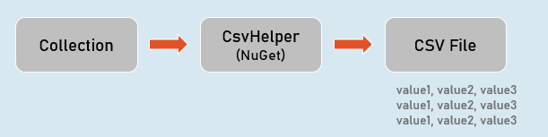

**CsvWriter:**

**WriteRecords(records)**

Writes all objects in the given collection.

Eg:

1,abc

2,def

**WriteHeader<ModelClass>( )**

Writes all property names as headings.

Eg:

Id, Name

**WriteRecord(record)**

Writes the given object as a row.

Eg:

1, abc

**WriteField( value )**

Writes given value.

**NextRecord( )**

Moves to the next line.

**Flush( )**

Writes the current data to the stream.

**Generate Excel Files (EPPlus)**

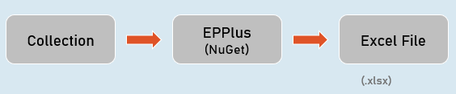

**ExcelWorksheet**

["cell_address"].Value

Sets or gets value at the specified cell.

["cell_address"].Style

Sets or gets formatting style of the specific cell.